Modern Cross Block February 2019 BOM due March Guild Meeting
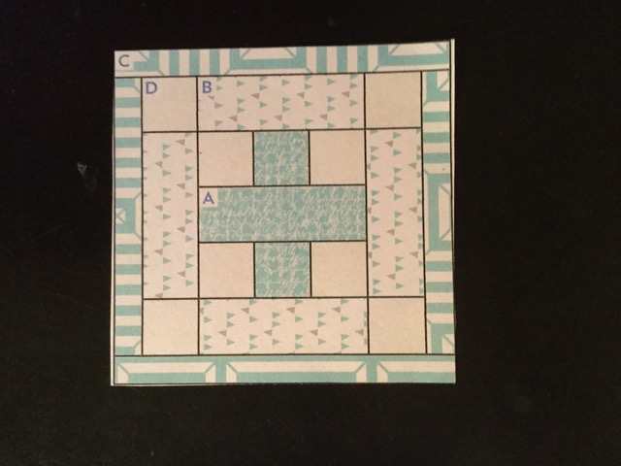

Fabrics
A: Any modern color to complement light grey
B: Small print to accent A and D
C: Omit unit C in this pattern
D: Light Grey solid
Cutting Out
Fabric A: One (1) 2½” x 6½” strip and two (2) 2½” squares.
Fabric B: Four (4) 2½” x 6½” strips
Fabric C: Omit in this block
Fabric D: Eight (8) 2½” x 2½” squares
Construction
*Sew one Fabric D 2½” square to each side of one Fabric A 2½” square. Repeat to make a total of two Fabric DAD units.
*Sew one Fabric DAD unit to each side of one Fabric A 2½” x 6½” strip to make the central unit.
*Sew one Fabric B 2½” x 6½” strip to the top and one to the bottom of the central unit.
*Sew one Fabric D 2½” square to each side of one Fabric B 2½” x 6½” strip. Repeat to make a total of two Fabric DBD units.
*Sew one Fabric DBD to the two remaining sides.
Block should measure 10½” x 10½” square.

