Intra-Guild SBQG May Block of the Month May 2019

Stripes from Strips
Due at June meeting
Pattern is courtesy of 32 Modern Quilt Blocks Publication.

Guidelines: Two fabrics. Fabric A: White with black print. Fabric B: Black with white print.
This two-fabric block is easy, fast, and fun. Please make more than one since they are small. Setting these blocks should be interesting and modern, maybe including some plain blocks.

Cutting Out
Fabric A: Three (3) 1 ½” x 6 ½” (You may want to use 7” for squaring to 6 ½”)
Fabric B: Two (2) 1 ½” x 6 ½” (Same comment as above) and Two (2) 1” x 6 ½” (Same comment as above)
See Figure 1.

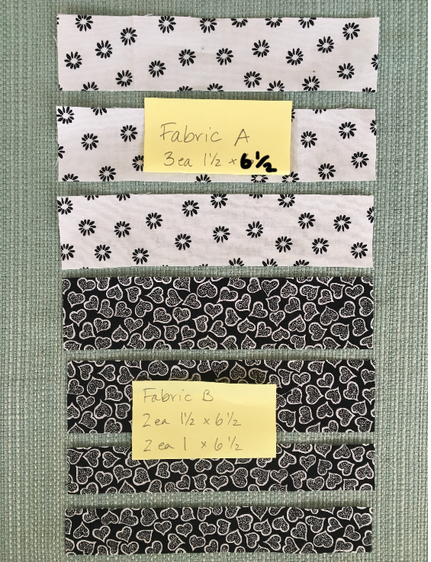
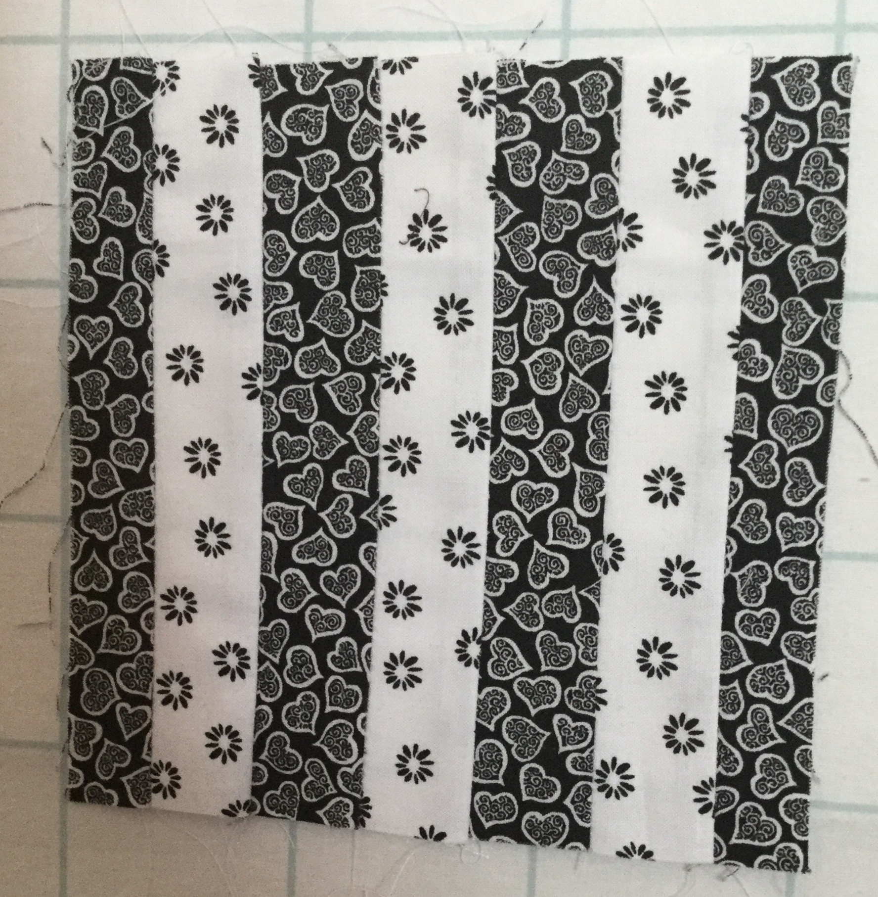
Figure 1. Figure 2.

Construction
*Sew the 1 ½” x 6 ½” strips together in the order ABABA along their long edges.
*Sew one Fabric B 1” x 6 ½” strip to each side of Fabric ABABA unit along their long edges.
* Trim to 6 ½” square.
* See Figure 2 for finished sample.

