PIECED HEART BLOCK
(Finished Size: 10” Square)

INSTRUCTIONS

This pattern is adapted from the on-line tutorial provided by Cluck Cluck Sew.
http://cluckclucksew.com/2015/01/making-heart-blocks-in-multiple-sizes.html

Cutting Instructions:
Print Fabric | 2 – 5-1/2” x 10-1/2”
Background Fabric | 2 – 5-1/2” Squares  4 – 2” Squares
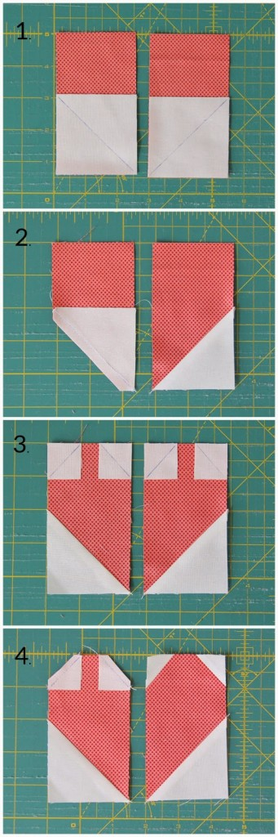

Assembly Instructions:

1. Draw diagonal lines on the wrong side of each
of the background squares. Place the two 5-1/2”
squares on the lower edge of each of the print strips.

2. Sew along the diagonal lines and trim the lower
corners ¼” from the seam lines. Open the background
triangles and press the seams open. (Pressing the
seams open makes it easier to match the seams
when you sew the two sides of the block together.)

3. Place the four 2” squares on the top corners of the
print strips, orienting the lines as shown.

4. Sew along the diagonal lines and trim the upper
corners ¼” from the seam lines. Open the background
triangles and press the seams open.

To complete the block, sew the two sides together along
the center, matching the angled seams, using a scant ¼”
seam allowance. The block should measure 10-1/2” square,
raw edge to raw edge.

Completed Block:


