HEART BLOCKS FOR UKRAINE

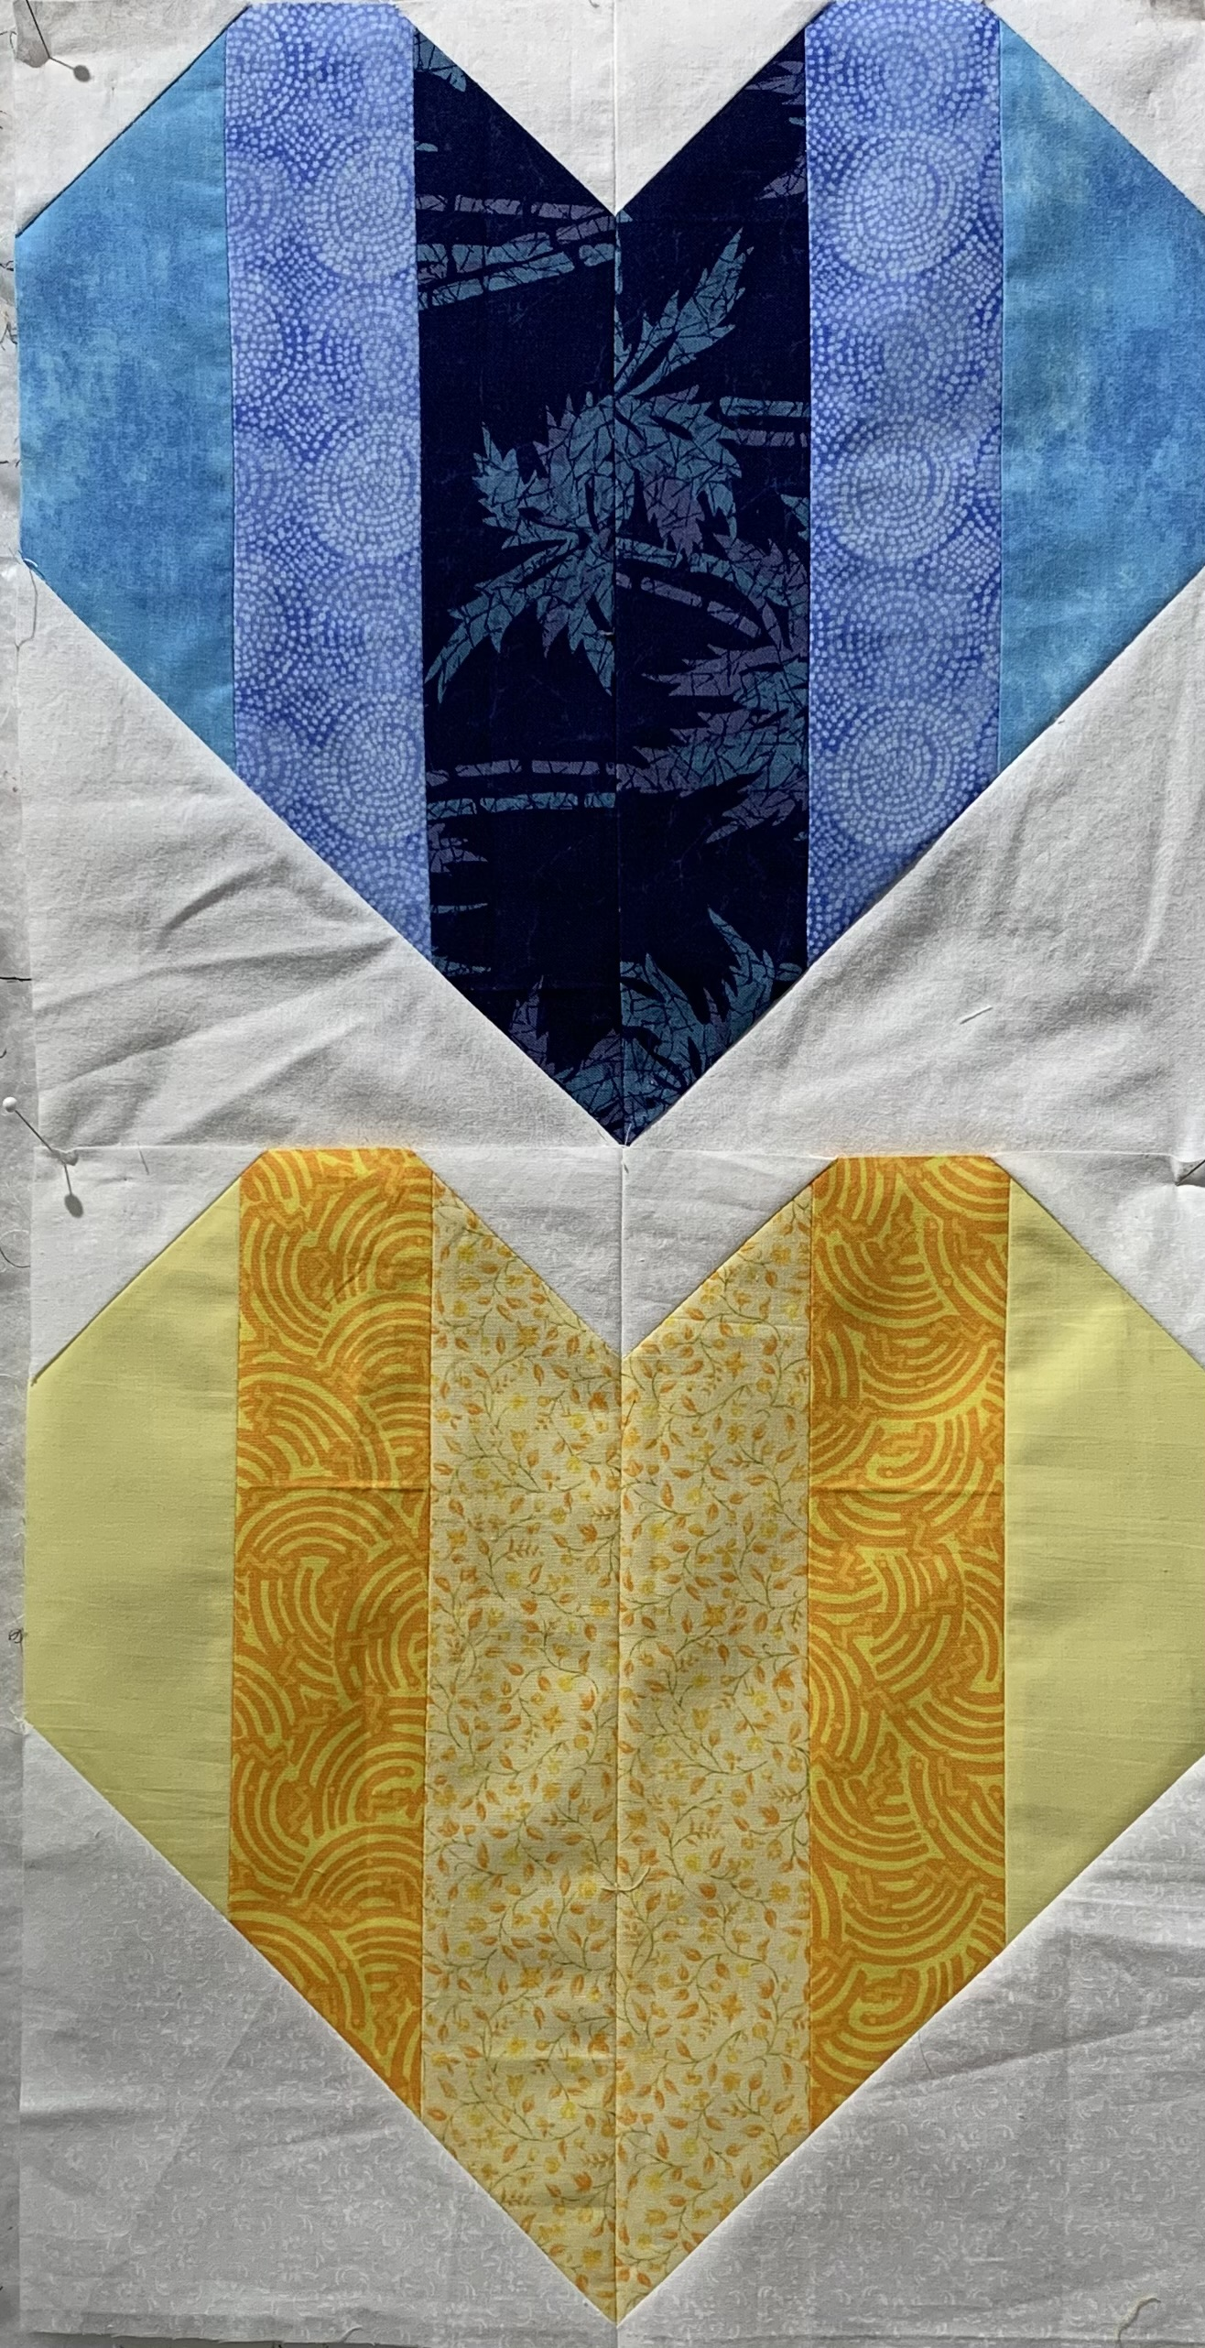

**For one Heart block you will need:**

**2 – 2 ½” x 12 ½” strips of 3 different blue (or yellow) fabrics (6 strips total)**

**4 – 6 ½” squares 2 – 6 ½” squares of background fabric (white, cream, tone on tone)**

**8 – 2 ½” squares 4 – 2 ½” squares of background fabric (white, cream, tone on tone)**

**For 2 blocks: 6 – Block size: 12-1/2” raw edge (12” finished)**

**Instructions:**

1. Make the Heart Strip Units. Assemble and stitch together one strip of each of the three colors in your desired arrangement (such as dark/light/medium), to make a strip unit. Use a scant ¼” seam allowance. Repeat the same arrangement with the remaining three colors and sew together to make a second strip unit. Press all seams open. Measure your two Heart rectangles to be sure they are 6 ½” X 12 ½”; adjust seams if needed.
2. Add “Snowball” units on each rectangle. Draw a diagonal line across the wrong side of each 6-1/2” and 2-1/2” background square from corner to corner with a pencil. Place two identical 12-1/2” Heart rectangles, right side up, side by side. Rotate one Heart rectangle so that the two center strips are identical and the outside strips are identical (such as: dark/light/medium (rectangle 1) and medium/light/dark (rectangle 2).

For bottom (pointed) end of Heart): Place one 6-1/2” background square on the bottom end of each rectangle, right sides together, with the diagonal seams oriented as shown. Pin and sew on diagonal lines. Cut off the outer corner, leaving a ¼” seam allowance. Press the seam allowance down on the left rectangle and up on the right rectangle (to nest center seam), or press the seam allowances open.



For top end of Heart: Place four 2-1/2” background squares on top of the Heart rectangles, right sides together, with the diagonal lines oriented as shown. Sew, press and trim in the same manner as for the 6-1/2” triangles.



3. Complete the Heart Block. Sew the two Heart halves together and press that seam allowance in either direction. Congrats, your first Heart Block is complete! Please consider making two Hearts for our project (both a blue and a yellow). Thank you for supporting our Heart blocks for Ukraine project.

Return completed blocks to Nadine Kirk (any questions call/text 310/730-3402, call 310/328-6552 or email Nadinekirk@socal.rr.com).