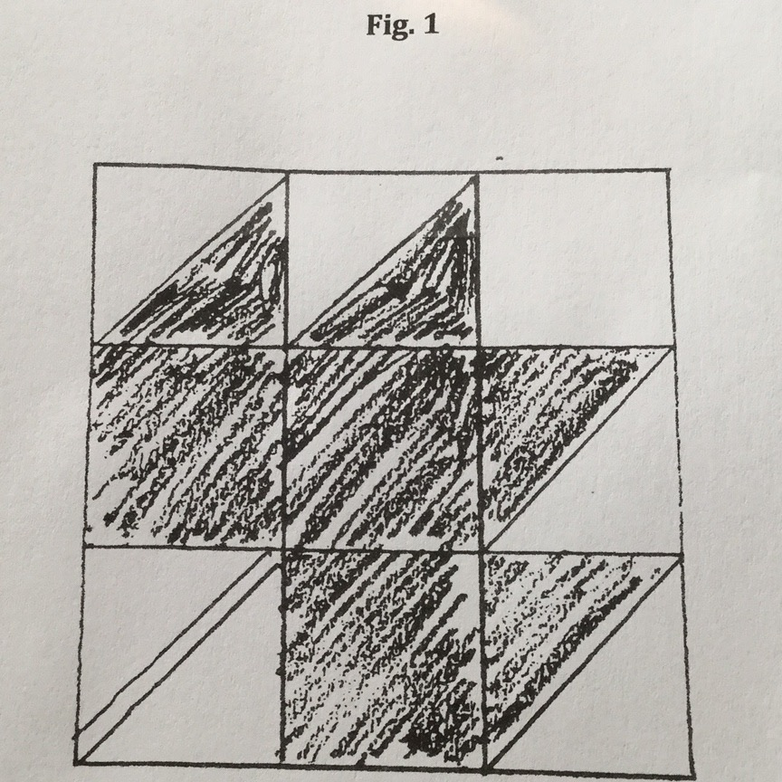
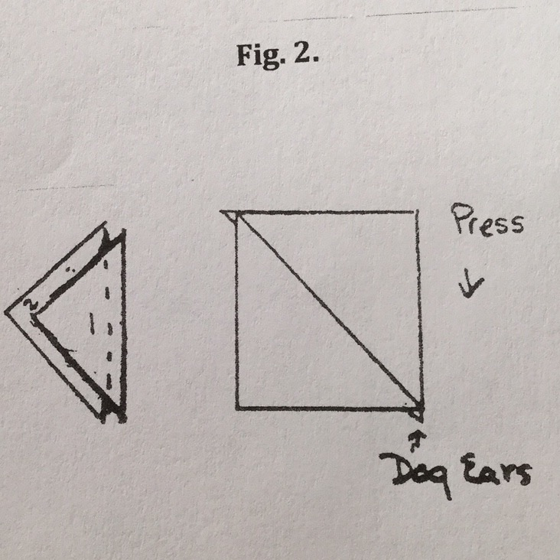
Intra-guild SBQG Block of the Month (BOM) March 2019 Modern Flare Leaf
Due at April Guild Meeting
For the March BOM, due at the April guild meting, we would like to have leaves of all sorts. They can be appliqued, pieced, paper pieced, embroidered, string pieced, or any other idea you would like to use to make the blocks. We would like them in 9 ½” unfinished size. Fabric should be any light or medium gray for background and any modern color/pattern for the leaf. Please be sure to keep the edges of your leaves well within the ¼” seam allowance around the block so that they are not cut off when the BOM winner incorporates them into his/her quilt.
For convenience, one maple leaf pattern is included here and a photo of a sample, as well a one photo of a string-pieced leaf, free-form cut, machine-appliqued onto a gray background. For fun and enjoyment, let your creative self play with an idea and make your own modern flare leaf design.

Maple Leaf with a Modern Flare Pattern/Instructions
Guidelines:
- Fabric 1: Use any gray for the background fabric.
- cut one (1) 3½” square
- cut three (3) 3 7/8” squares cut in half on the diagonal
- Fabric 2: Use any modern fabric color or pattern for the leaf.
- cut three (3) 3½” squares
- cut two (2) 3 7/8” squares, cut in half on the diagonal
- Fabric 3: For the stem, use any color to coordinate fabrics 1 and 2.
a. cut one (1) ¾” by 6” rectangle.
4. For the stem square, sew a background triangle to each long side of the stem. Trim the block to 3½”.
5. Sew together as shown in Fig. 1.

Quilting 101: A half-square triangle is a square made of 2 triangles. One way
to make a half-square triangle is to cut a square 3/8” larger than the desired
half-square triangle out of two fabrics, then cut them on the diagonal. (If the half square triangle is to be 3 ½” then cut squares 3 7/8”). Stitch, press, and trim the “dog ears” as shown below in Fig. 2.

