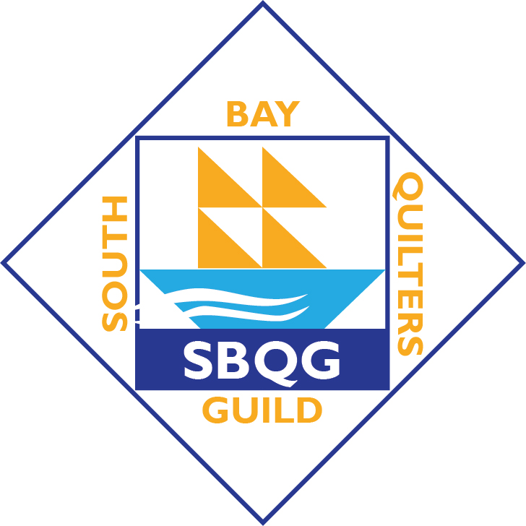

PERKIOMEN VALLEY BLOCKS FOR UKRAINE
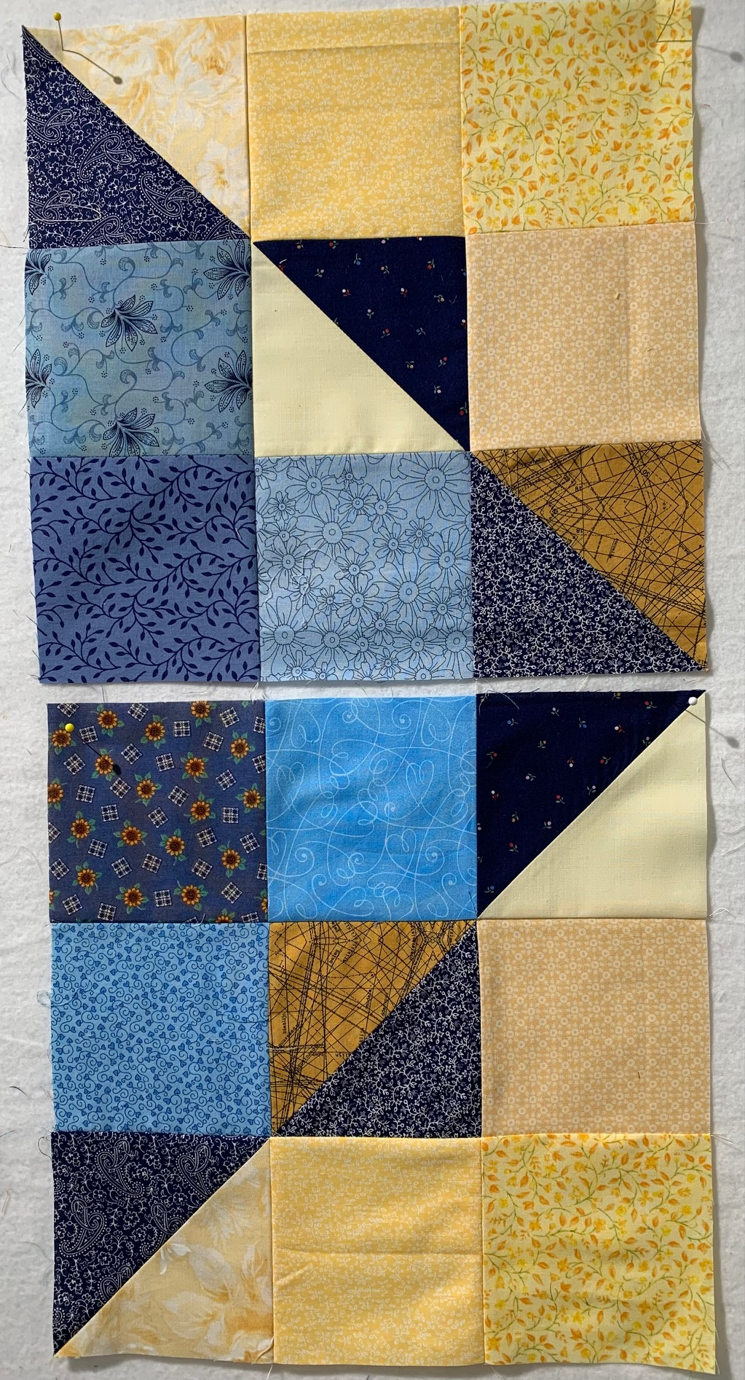
For 2 blocks: 6 – 4-1/2” blue squares
6 -- 4-1/2” yellow/gold squares
3 – 5” blue squares
3 – 5” yellow squares
Use the 5” squares to make 6 half square triangles (3 different HST for each block) at 4-1/2”. Reverse one HST in the center of the blocks (see photo). Do not repeat any fabric in the blocks. Block size: 12-1/2”

Return completed blocks to Nadine Kirk (contact info is in the Guild directory for any questions).

