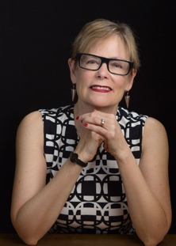 | July 2023 – Meg Cox  July 18, 2023  “Quilt Journalist Tells All.. A Reporter Inside the Quilt World” (Zoom)  Website: https://megcox.com | 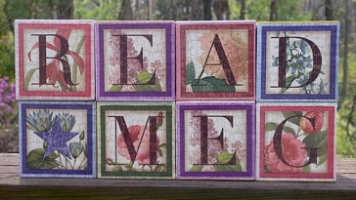
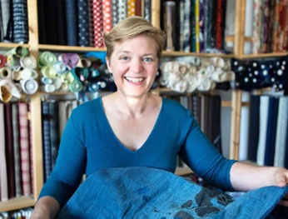 | August 2023 – Carol Ziogas  Aug 15, 2023 “Stitching the Sky – 19th Century Japanese Indigo, Sashiko and Born Textiles” (Zoom)  Aug 16, 2023 Workshop “Sashiko for Beginners” (Zoom)  Learn sashiko techniques with a sampler  Website: theardenthread.com | 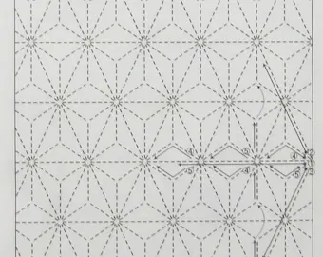
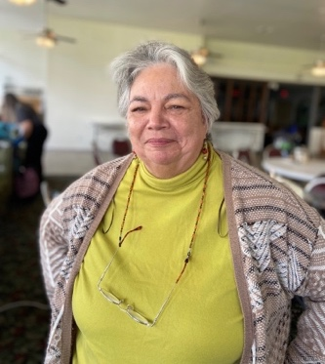 | Sept 2023 – Frances Moore  Sept 19, 2023 “Never Say Never… Life Lessons From Quilting” (In Person)  Sept 23, 2023 Workshop “Really Free Free-Motion Quilting” (In Person)  Learn free motion quilting  Website: https://frantastic-stitchwitchery.blogspot.com
 | October 2023 – Diane Harris  Oct 17, 2023 “Taste Test Trunk Show: Unexpected Sampler Quilts” (Zoom)  Oct 18, 2023 Workshop “Intro to Improv: Scrappy Adventures” (Zoom)  Improvisation techniques  Website: stashbandit.net | 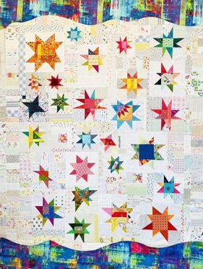
 | November 2023 – Karen Brown  Nov 21, 2023 “Be the Best Quilter You Can Be” (Zoom)  Website: Justgetitdonequilts.com | 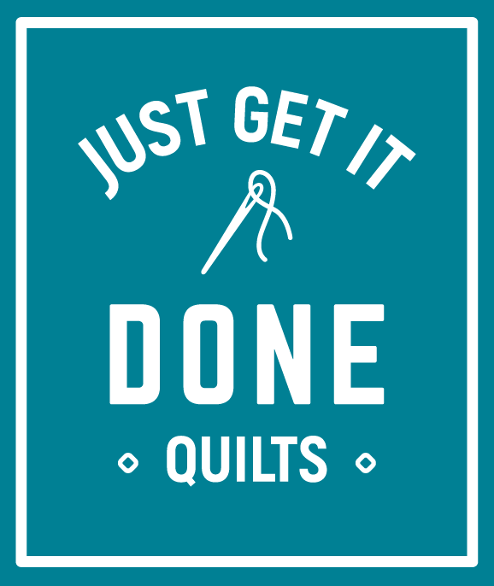
 | December 12, 2023 – Holiday Party
 | January 2024 – Reed Johnson  Jan 24, 2024 “Reinventing Yourself: From Trial Attorney to Nationally Known Quilt Designer w/ Trunk Show” (Zoom)  Website: bluebearquilts.com | 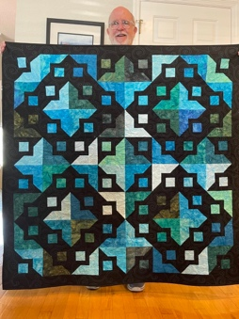
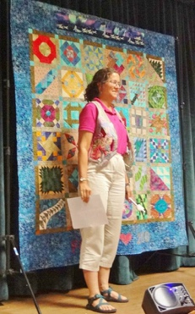 | February 2024 – Anne Sonner  Feb 20, 2024 “Vintage to Modern” (In Person)  Feb 24, 2024 Workshop “SBQG By the Sea” (In Person)  Foundation paper piecing  Website: annesonnerquilts.wordpress.com | 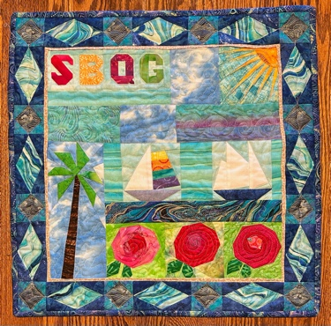
March 2024 – Quilt Show Wrap Up

March 19, 2024
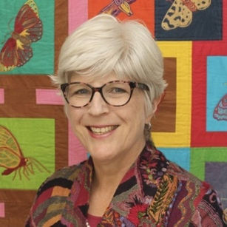 | April 2024 – Catherine Redford  Apr 16, 2024 “Trip Around the World in Folk Art Stitches” (Zoom)  Apr 20, 2024 Workshop “The Wool Applique Experience” (In Person)  Learn wool applique and make a small project  Website: catherineredford.com | 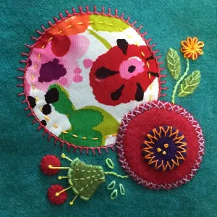
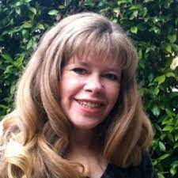 | May 2024 – Alex Tsubota  May 21, 2024 “Landscapes – From Here to There” (In Person)  May 25, 2024 Workshop “Landscapes Made Easy” (In Person)  Learn how to create a landscape quilt | 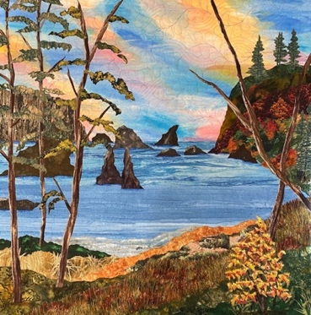
June 18, 2024 – Annual Wrap Up Party

Food, Friends, and Quilt-Tying

