LOG CABIN BLOCK
(Finished Size: 10” Square)

INSTRUCTIONS

Fabrics: Tone on tone or print fabrics work for this scrappy block. Use red for the center square, three light blues for one set of logs and three dark blues for the other set of logs. Logs are added in the order of two light logs, then two dark logs, for each round. To keep track of the scrappy logs, note the numbers in the chart below (A1 and A2 are the first two light blue logs; B3 and B4 are the first two dark blue logs, etc.).

Cutting Instructions: Assembly Diagram:

Center Square | Finished Size: 2-1/2” | Cut Size: 3”  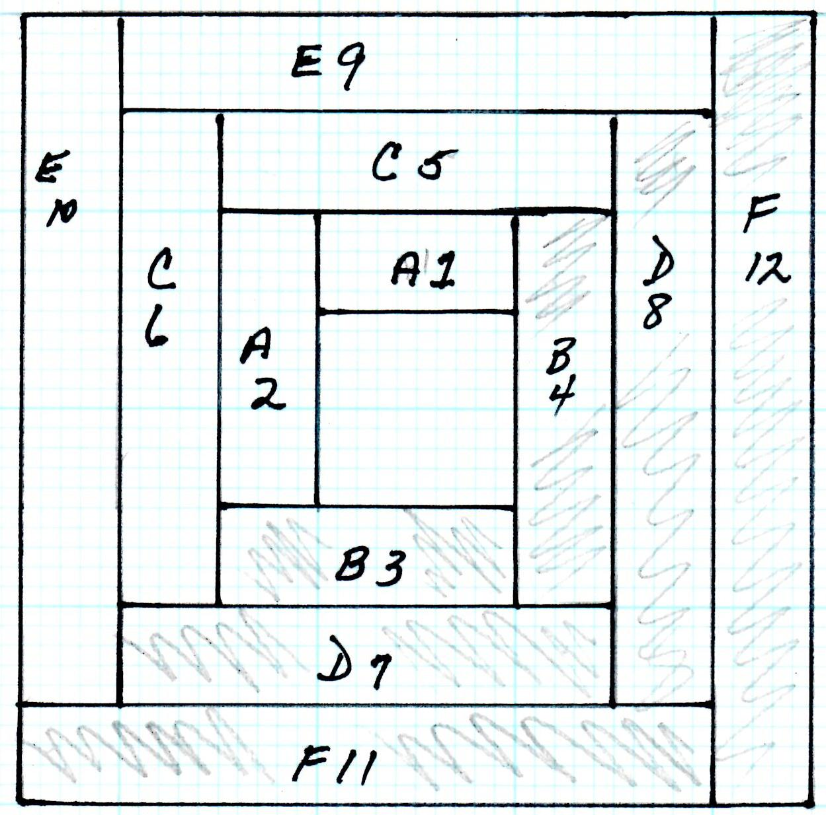

Light Blue Logs
Sewing Order | Finished Log Size | Cut Log Size
A1 | 1-1/4” x 2-1/2” | 1-3/4” x 3”
A2 | 1-1/4” x 3-3/4” | 1-3/4” x 4-1/4”
C5 | 1-1/4” x 5” | 1-3/4” x 5-1/2”
C6 | 1-1/4” x 6-1/4” | 1-3/4” x 6-3/4”
E9 | 1-1/4” x 7-1/2” | 1-3/4” x 8”
E10 | 1-1/4” x 8-3/4” | 1-3/4” x 9-1/4”

Completed Block:

Dark Blue Logs
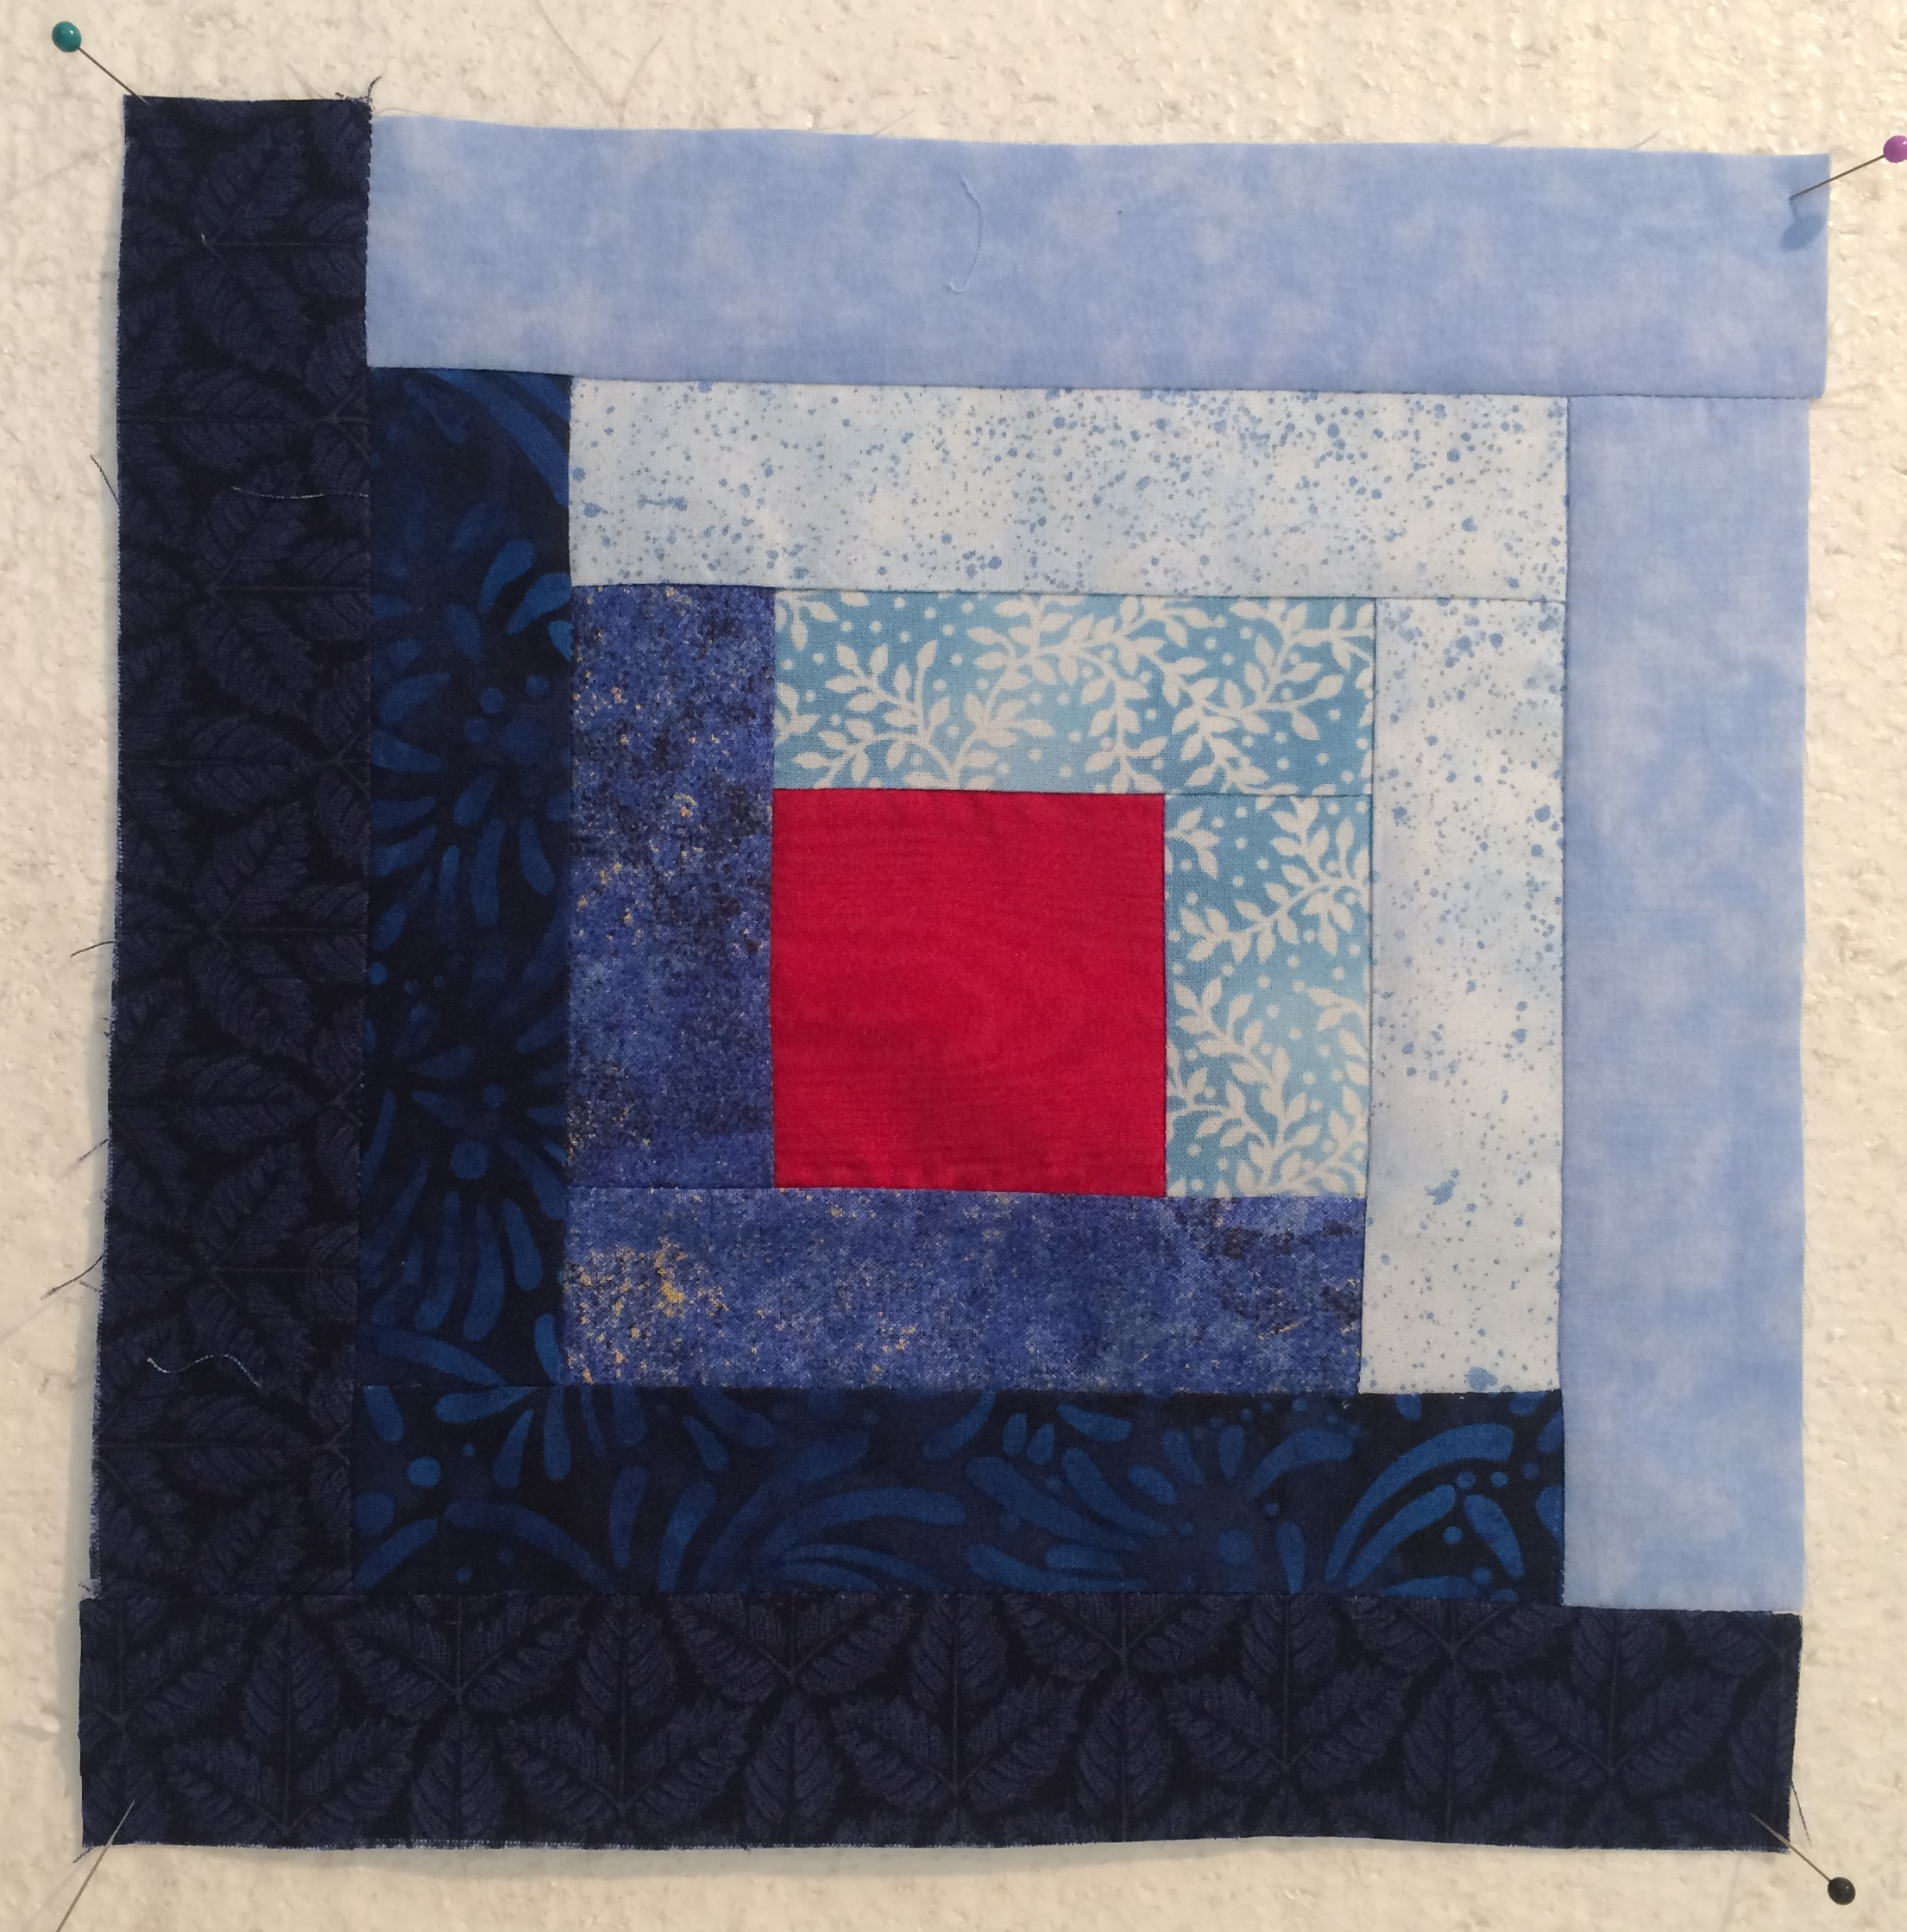
Sewing Order | Finished Log Size | Cut Log Size
B3 | 1-1/4” x 3-3/4” | 1-3/4” x 4-1/4”
B4 | 1-1/4” x 5” | 1-3/4” x 5-1/2”
D7 | 1-1/4” x 6-1/4” | 1-3/4” x 6-3/4”
D8 | 1-1/4” x 7-1/2” | 1-3/4” x 8”
F11 | 1-1/4” x 8-3/4” | 1-3/4” x 9-1/4”
F12 | 1-1/4” x 10” | 1-3/4” x 10-1/2”

Assembly Instructions and Hints:
Start with the red center square and add the first light blue log (A1). Press the seam towards the log (do this on all seams to avoid bulk). Add the second light blue log (A2) as shown on the diagram, then press. (Press after each log is added, before adding the next log.) Piece the block in the sewing order shown in the table above, and starting with log B4 always add the next log to the side of the block that has two seams. Accurate ¼” seam allowances are important. Hint: As you assemble the block, if the new log seems to be too short, take a slightly wider seam allowance (the block is too large). If the new log seems to be too long, take a slightly narrower seam allowance (the block is too small). The block should be square after each round is added. The completed block should measure 10-1/2” square, raw edge to raw edge.

