BLOCK OF THE MONTH
October Newsletter Due November 2019 R2/D2 9-Patch

Size: 9½” Block Unfinished

Colors: 1. Your choice of plain white or white-on-white
2. Any bright solid fabric or reads as solid fabric

Cut: White or white-on-white

Four 4) 3 ½” squares the four corners of the nine patch
One (1) 1 ½” x 15” strip
Two (2) 1” x 15” strips

Cut: Any bright solid or reads as solid

One (1) 3 ½” square the center of the 9-patch
Two (2) 1” x 15” strips

Assembly:

Sew one each of the bright and the white 1” x 15” together. Then do the same for a second set. Press. Now assemble the two strips, bright sides to each side of the single 1 ½” x 15” white strip. Press. Square up one end of this striped piece then cut into 3 ½” squares. You should have four squares.

Assemble Row 1, 2, and 3. Then assemble the rows together as a nine patch. See Figure 1. When the blocks are assemble into a quilt, see Figure 2.

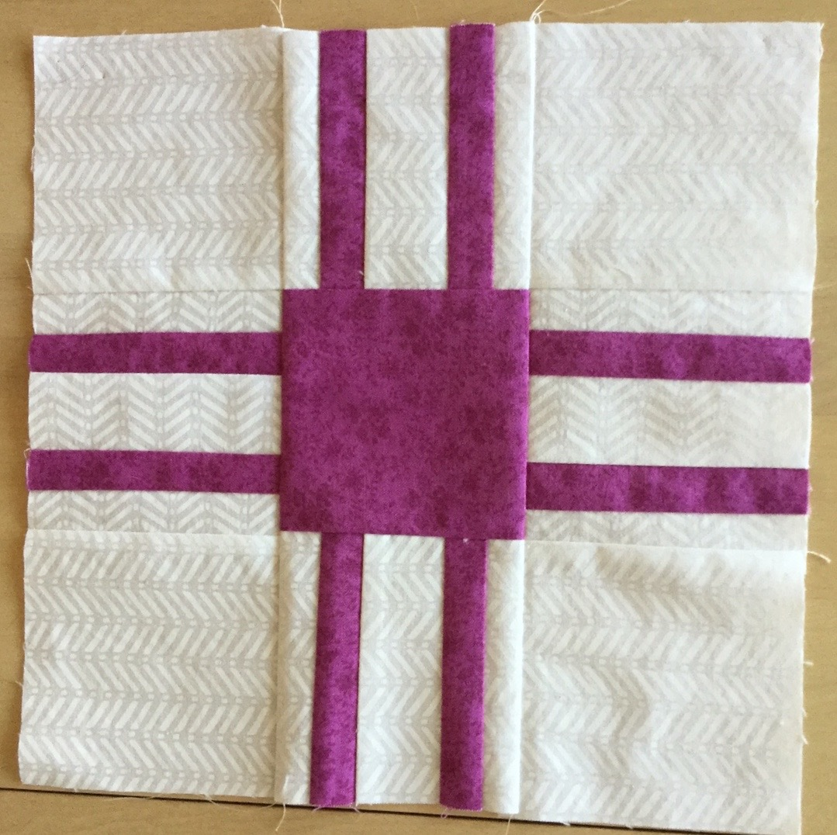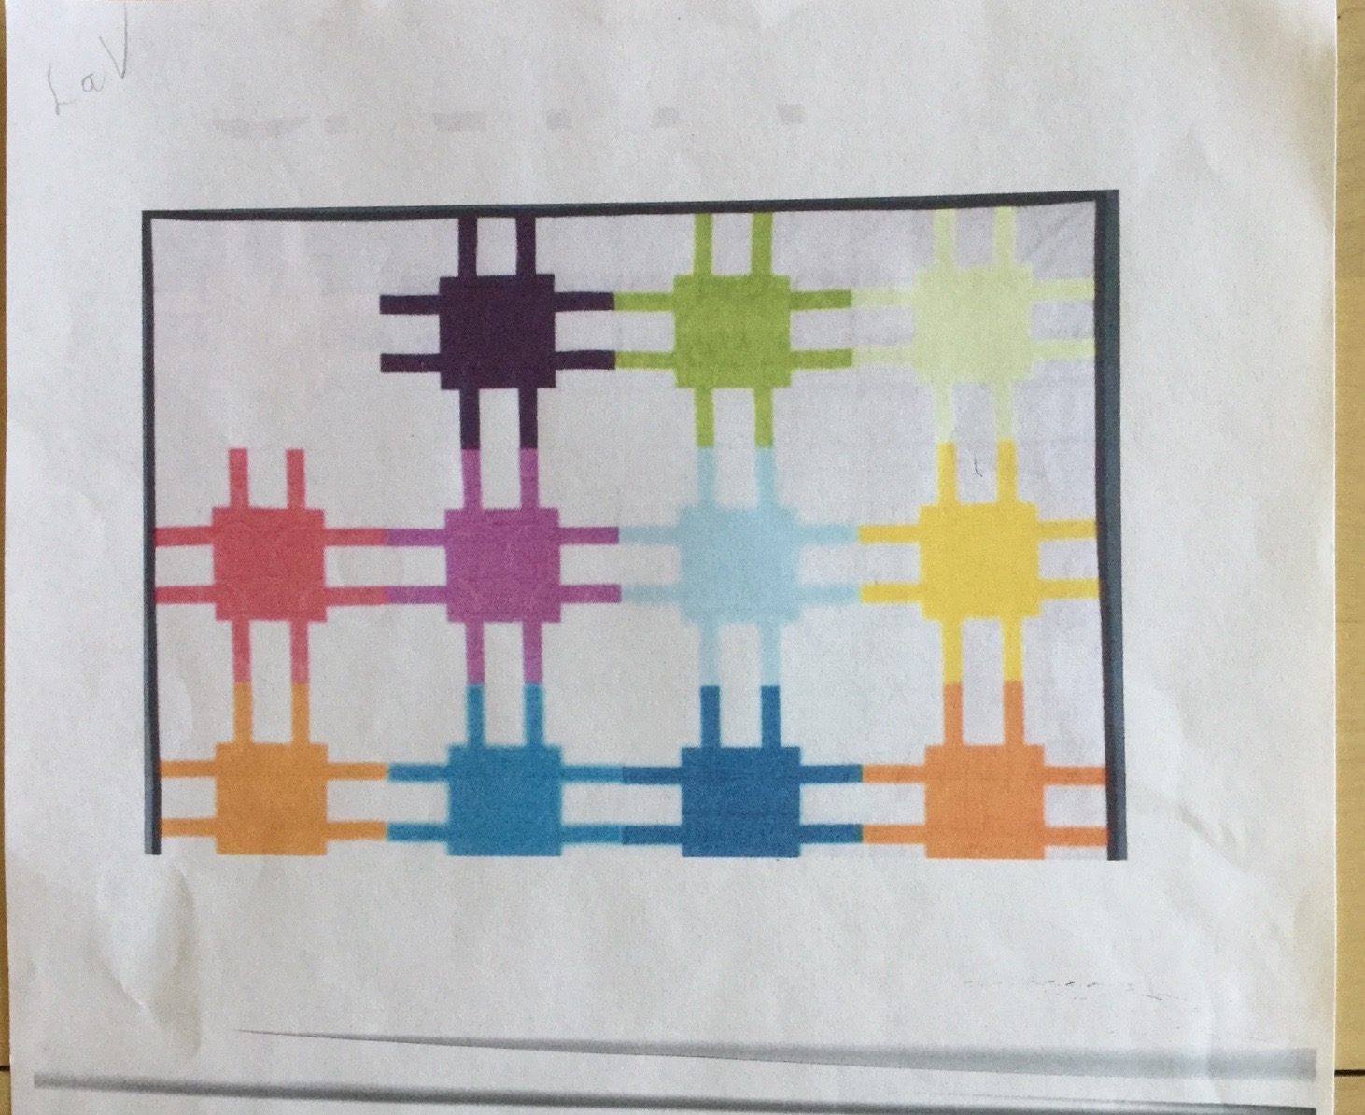
Figure 1 Figure 2

